Abstract—Interacting with people and places all over the world is easier than it has ever been, however, such interactions are typically restricted to online communications. Being physically “somewhere else” in the world while using telepresence or virtual reality (VR) in your own home is inaccessible in the consumer market and extremely expensive in the corporate market due to extraneous software/features and compensation for research time. Such technology may facilitate meaningful human connections beyond the reach of one’s own physical body, including visiting an area of interest on a different country or continent. Additionally, such technology could prove beneficial to people with limited/no mobility due to disability. To bridge the gap between virtual reality and physical reality, we developed a prototype of a teleoperated robot-on-wheels controlled in VR over Wi-Fi, using hand-held VR controllers and a VR headset. Dual stereoscopic cameras mimicking human eyes mounted on the robot stream video from the cameras to the corresponding eyes in the headset via a Unity project. The captured video was encoded and streamed while simultaneously processing positional data from the VR client without overheating or throttling. Testing indicated the video latency (less than 400 ms) and quality (720p 30fps) are sufficient to mitigate motion sickness and allow for a reasonably smooth experience when using the robotic platform.
Cost-effective Telepresence Robot Operated using Virtual Reality*
Dylan OBrien, Owen Terry, and Tahmid Latif, Member, IEEE

INTRODUCTION
Virtual reality or VR is a great tool for many recreational purposes and is finding use in education and tourism [1]-[3]. An estimated 65.9 million people used virtual reality in the United States alone in 2023 [4]. While many of these users primarily use VR for games or social interactivity, the increasingly powerful technology provides an opportunity to do something beyond games and become more pragmatic: taking the “reality” of virtual reality to its absolute limits. The primary use case for VR technology is almost exclusively for interacting with people or things in a wholly virtual space; anything that happens within the virtual reality headset is generally constrained to an entirely virtual world and is not affected by or has no effect on the real one. However, with existing technology, it should be possible to use VR as a means of interacting with the real world through use of a secondary medium like a machine or a robotic vehicle. Sitting from the comfort of their home, a VR user can “drive” the robotic vehicle using handheld controllers and look at the robot’s surroundings through the robot’s “eyes” using a VR headset. The applications of such a creation can be limitless, and are focused on the telepresence of the user and their experience. These applications can range from allowing prospective students to join a live campus tour at universities across the world to enhancing industrial automation. Additionally, a more important application can be as a piece of assistive technology for bedridden patients to extend themselves outside of their usual range of influence, thereby improving their quality of life.
The notion of controlling a robot in VR was previously attempted in a commercial capacity stocking shelves [5] and in academic research to test the viability of a VR-controlled robot [6]-[8]. Both robots were highly specialized to perform their designated tasks, however, they do not generally appeal to the average user outside of those tasks. The other alternative to attempting a general solution is Reachy (Reachy, Pollen Robotics) [9]. Reachy is a commercially available robotic platform sold as a stationary robot as well as with a mobile platform, with the latter costing upwards of USD 40,000 [10]. All of the underlying features in Reachy are completely open source [11]. These include hardware information, CAD models of all the parts, and even all of the Python-based software. One of those features include a package for Unity which facilitates seamless integration between ROS (Robot Operating System) and Unity itself [12]. This package has been used in other instances at controlling robots in VR [13], and could prove to be invaluable for relevant works on both the robot itself and any complex robotic appendages. These open-source features could be adapted into developing a cost-effective and reliable VR-controlled robotic platform accessible to a wider pop-ulation for a generalized use case.
The goal of this work was to bridge the gap between virtual reality and physical reality by developing a cost-effective teleoperated robot that could be controlled over Wi-Fi in VR. The development of the teleoperated robot was realized in the form of a single-board computer (Raspberry Pi 5, Raspberry Pi Foundation)-based platform with a motorized mobile base, dual cameras for stereoscopic video feed, and relevant sensors (Fig. 1). The video feed streamed to the VR headset (Quest 2 headset, Meta Platforms, Inc.) helped a user see the robot’s surroundings and control or teleoperate the robot using hand-held VR controllers (Quest 2 controllers, Meta Platforms, Inc.). It was imperative to keep the video latency below an absolute limit of 800 ms to ensure user comfort when viewing the streamed video and working in VR [14]. Additionally, the smoothness in locomotion of the robotic platform was ensured for a satisfactory user experience.
The work has been summarized in this paper into the following sections: Section II details the development methods and materials used; Section III details the testing procedures; Section IV discusses the preliminary results; and Section V concludes the paper and proposes potential future directions of the work.

Materials and Methods
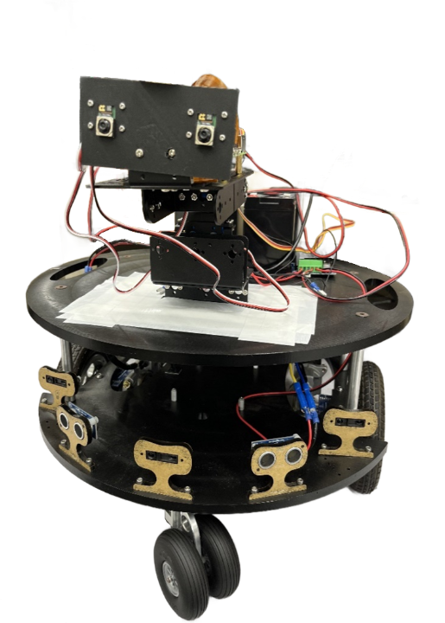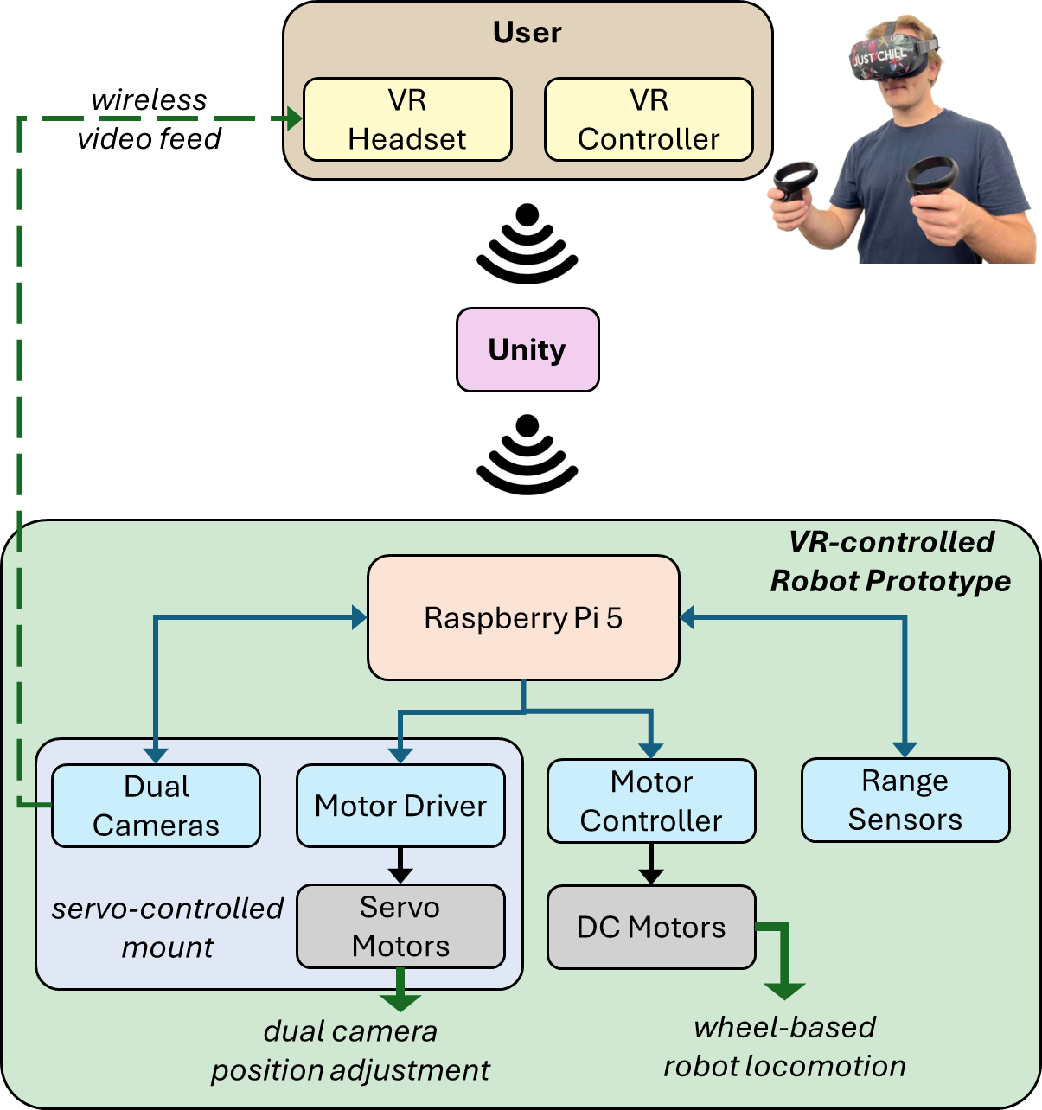
Figure 1. (left) Teleoperated VR robot prototype shown with a servo-controlled dual camera mount attached on the top of the motorized base. (right) The process flow diagram of the prototype.

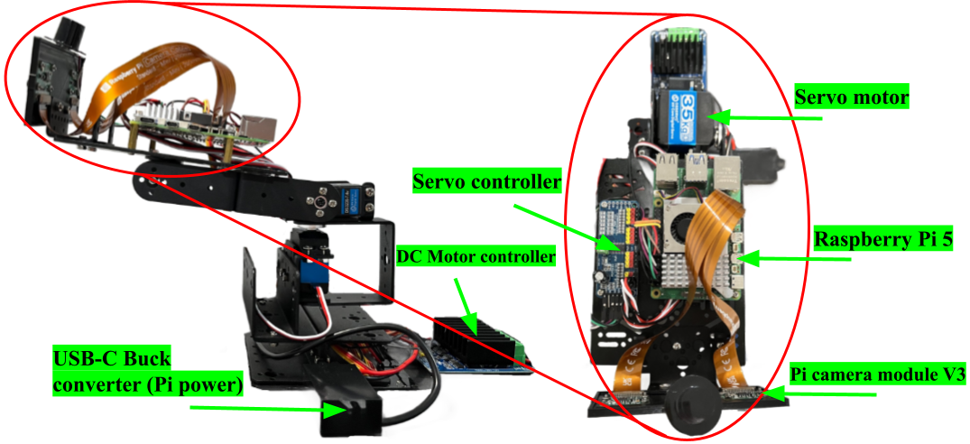

Figure 2. (left) Profile view of the servo-controlled mount with a servo motor at the base, Raspberry Pi on the top link, and fixture with the dual cameras visible at the top-right. (right) Top view shown with the Pi and relevant components.
The design phase of this work was split up into four main parts: the motorized base, a servo-controlled mount for the cameras, the Python and C# scripts to facilitate communication between the microcontroller and Unity respectively, and finally the Unity project itself.

A. Motorized Base
The motorized base on wheels was assembled using components from a commercially available kit (Eddie Robot Platform, Parallax Inc.). The reused kit included acrylic plates for bases, two 12V DC motors (730556-7030, Denso), four wheels (two for the motors, and two swivel wheels for balance), basic range sensors, among other things. The motorized base included the acrylic plates, the wheels, and the motors. Additional components, including the single-board computer and batteries, were acquired and added to the base, as discussed in the following sub-sections. The fully assembled 45.2 cm wide base stood 55.25 cm high, and had a maximum payload capacity of 22.7 kg.

B. Servo-controlled Mount
The servo-controlled mount was a metallic 2-DOF robotic arm structure. The mount was bolted onto the top acrylic plate on the motorized base, and had space for the Raspberry Pi 5 and the batteries (Fig. 2). The arm structure had two high torque servo motors (DS3235SG180, ANNIMOS). One of the motors was attached to the base of the structure to control the yaw (lateral movement) while the other controlled the pitch (vertical movement) of the end fixture where the dual cameras were mounted. The intended design was meant to give the user ability to look around while ‘driving’ the robot with minimal rotational movement of the robot base, unless required.
A 16-channel servo motor driver (PCA9685, HiLetgo) was used with the motors. With two channels used, this left room for the implementation of additional motors. This meant, as a future prospect, the robotic arm could be duplicated to include a hand-type end-effector that could be manipulated using the hand-held VR controller.

C. Coding Scripts
For this work, the brain of the robot was a Raspberry Pi 5, a single-board computer with an ARM-compatible microprocessor, provisions for sensor/peripheral interfaces, and Wi-Fi capability. Additionally, it had native support for streaming videos from dual (stereoscopic) cameras to a VR headset via a Unity project.
One of the most important parts of this work was the Python and C# scripts used to facilitate communication between the Raspberry Pi and Unity. There were six primary scripts (two per robot function): two for sending and receiving video, two for sending and receiving robotic movement controls, and two for sending and receiving movement control for each of the servo motors on the robotic arm. All of the scripts used sockets to send and receive data over Wi-Fi, specifically the Python scripts use the Python sockets library and the C# scripts use the System.Net.Sockets library. What made transferring all the different data types possible was the way they were packaged by the Pi. Using another library in Python called structs, it was possible to take any data type being handled in Python (specifically video data in this instance) and convert it directly into chunks of raw data that could then be sent to the Unity script to be interpreted. A GitHub repository was created to store the relevant scripts necessary for robotic operation.

D. Unity Project
Unity was used to receive all the data from the Raspberry Pi and allow it to be interfaced using VR. Unity was the best solution due to the simplicity with which a VR application can be created and because of the availability of libraries which helped implement many of the niche use cases needed in this work. The setup used a default 3D template for Unity and then imported the OpenXR package to interface with VR. Unity especially excelled at handling scripts in general and the loading of scripts into the VR scene. Each script was tied to a GameObject, an object that defined an element in VR (CHEK def). Each GameObject acted as its own separate module with its own script that was tied to it. For example, the cameras, movement, and servo control were all different GameObjects, and they could be turned on or off at will so that they could be effectively tested/used. A future implementation of audio feedback should be as simple as creating additional GameObjects to hold the scripts for sending and receiving the audio data from the Pi.

Video Streaming and Robot Control
The prototype VR robot platform was tested in multiple stages with focus on the following: dual-camera functionality with live camera feed streaming to a VR headset, video latency, controllability of all intended movements with a hand-held VR controller, and interaction with a Unity scene.
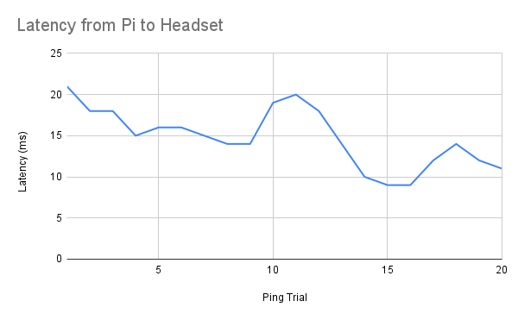
Figure 3. Latency plot for one-way data communication from the Pi to the VR headset.
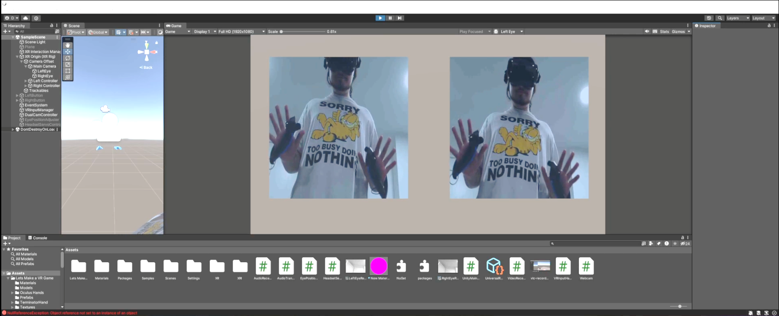

Figure 4. Video from the dual cameras sent to the Unity project via Wi-Fi. Unity in turn streamed the video to the user’s VR headset. Image shows a video feed from the dual cameras as seen on Unity.

A. Latency
To test the system latency, the entire communication structure from the Raspberry Pi to the VR headset was thoroughly examined. The IP address of the Raspberry Pi was pinged multiple times to measure the round-trip time of data packets. Across all tests, the average latency between the Pi and the host computer remained under 20 ms, with no packet losses observed (Fig. 3). With the addition of cameras streaming in VR, the system was capable of streaming 720p 30fps video with latency ranging from 150-300 ms, depending on the quality of the internet connection. The total latency including video transmission was measured between 150 ms and 400 ms, with occasional spikes that could reach up to 700 ms during network load or with rapid movements of the camera/robot.

B. Camera
Testing the dual-camera setup was critical to the work since the live feed from the cameras was directly streamed to the VR headset to create a stereoscopic view in the Unity scene (Fig. 4). Both cameras were tested to ensure they worked in perfect synchronization without perceptible lag between them. The cameras were set to stream video at 1080p 30fps using H.264 encoding over a UDP connection (Fig. 5). During testing, the average latency of video streaming was found to be between 150-300 ms. Testing also focused on ensuring that the Unity scene rendered the camera feeds correctly, with adjustments made for field of view and depth perception.
Occasional delays were observed to be around 700 ms during more intense processing periods with rapid movements of the camera/robot. Maintaining synchronization between the cameras during such periods proved to be a challenge and is currently being investigated.

C. Movement Control of the Robot Platform
Initial small-scale prototypes were simpler and controlled with a laptop keyboard and smaller DC motors, the current iteration was designed with larger DC motors powered through a motor controller using pulse width modulated (PWM) inputs for speed control. Investigating controllability or teleoperation of the robot involved testing the robot’s ability to respond to commands from the hand-held VR controllers with precision and stability. The PWM inputs allowed for stable and precise movements, with smooth transitions between directions. Tests focused on the responsiveness, reliability, and stability of the robot while in
motion. The robot’s movement was generally smooth and responsive, with minor vibrations observed during fast-paced movements or sudden stops. These were minimized through fine-tuning the pulse-width modulated speed control of each motor.
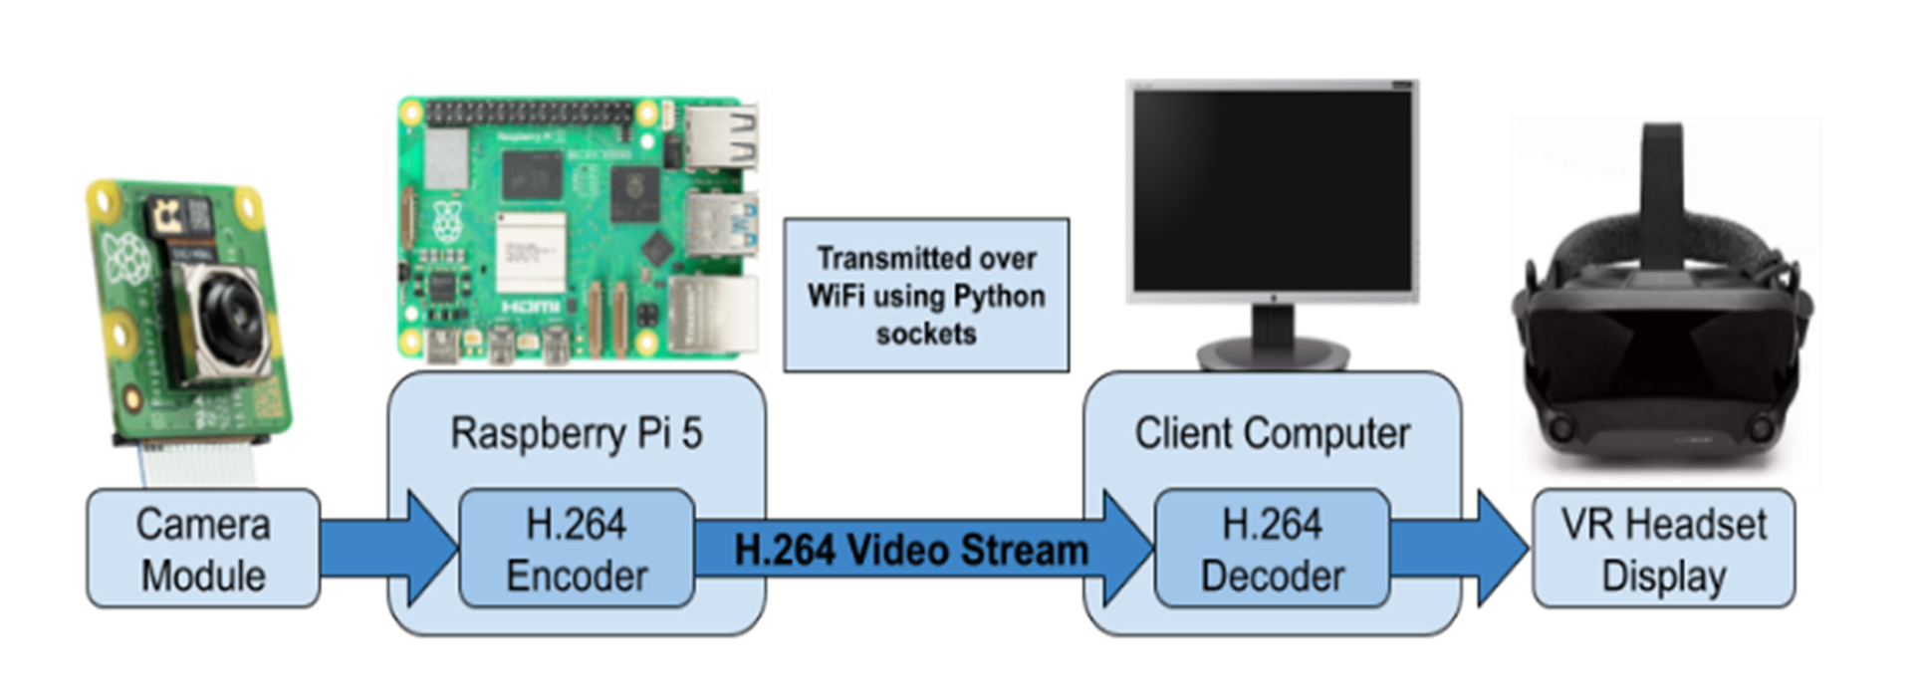
Figure 5. Process flow diagram of the video encoding/decoding pipeline.
- Bill of Materials
Item | Unit Cost | Qty. | Total
Raspberry Pi 5 | $ 80.00 | 1 | $ 80.00
Raspberry Pi power supply | $ 15.00 | 1 | $ 15.00
Raspberry Pi cooling unit | $ 5.00 | 1 | $ 5.00
12V DC motor | $ 30.00 | 2 | $ 60.00
Wheels for motors | $ 20.00 | 2 | $ 40.00
Supporting swivel weeles | $ 15.00 | 2 | $ 30.00
12V 10Ah LiFePO₄ batteries | $ 30.00 | 2 | $ 60.00
DC 12V to 5V step down converter | $ 10.00 | 1 | $ 10.00
DC buck converter | $ 15.00 | 1 | $ 15.00
H-bridge motor driver | $ 15.00 | 1 | $ 15.00
Servo motors for mount | $ 25.00 | 2 | $ 25.00
Servo motor driver | $ 7.00 | 1 | $ 7.00
Pi camera module 3 | $ 25.00 | 2 | $ 50.00
Quest 2 VR headset and controllers | $ 300.00 | 1 | $ 300.00
Grand Total | $ 712.00

Additionally, the power consumption was measured showing an average draw of 6 W, giving an estimated battery life of 15 hours under typical operating conditions.

Discussion and Future Directions
The developed prototype was a test case to investigate the prototype VR-controlled robot and the feasibility of translating on to a larger and more functionally robust platform. To assess controllability, functionality, user experience of the prototype, and gain overall feedback on the design, users teleoperated the robot using the VR headset and controller inside a basketball gymnasium. The users were able to control the robot’s locomotion in a stable and precise manner with the hand-held controllers. Keeping the user-centered design of this work in mind, the testing focused on user experience in addition to the optimal operational capability of the robot.
We were able to accomplish fast communication between the Raspberry Pi and Unity over Wi-Fi and confirm that the system could handle streaming video from the dual cameras while simultaneously sending signals to its ports. The video latency for the 720p 30fps video streamed to the VR headset was typically under 400 ms. This was within acceptable limits for teleoperated VR applications [14]. Nevertheless, occasional spikes in delay underscored the need for continued optimization, particularly in network and video processing. Future directions would optimize the synchronization and latency of the dual-camera setup to ensure a seamless and immersive VR experience for the user. Refinement in motor control and vibration damping would also be an added component to stabilizing the video feed and further improving the user experience.
The modularity of the design is also evident from the plug-and-play nature of the Unity project as well as the simplicity and lower cost of the robot platform’s development and construction. A total of about $ 712.00 was spent on the several components used (Table I). With a few hundred more dollars for a robot base, the entire platform could be developed for less than $ 1,000.00. This amount is less than one-tenth of commercially available VR-operated telepresence platforms.
There are other avenues of improvements and additions, such as robotic arm manipulator(s) with hand/gripper-type end-effectors to interact with the robot’s surroundings, two-way audio communication, and additional sensors for obstacle detection and avoidance. While the motorized base was equipped with traditional obstacle avoidance sensors, the presented work did not include any obstacle avoidance or path planning algorithms, and lacked robot autonomy. The prototype relied solely on teleoperation by the user with the VR headset and hand-held controllers. Additional work would need to be performed on the robot base or chassis. With the current height of the robot at 55.25 cm, we are scaling up the design to make it more functional and comparable to human height.

Conclusion
This work developed a prototype teleoperated VR robot that can enable telepresence across borders. The greater application can even assist people with limited or no mobility to take part in immersive experiences from a place of comfort. The feasibility of creating a cost-effective platform played a significant role in the design and development of the work. This work makes contribution towards VR robot research by addressing the key challenges of latency, movement, and dual-camera functionality. The platform performed with a responsive user experience and successfully streamed 720p 30fps video with a latency ranging between 150-400 ms, a range that is within acceptable limits for teleoperated VR applications.
This work serves as a proof of concept for the potential of cost-effective VR-controlled telepresence robots, highlighting the need for continued research and development in the field. The work completed here lays a strong foundation for future iterations that could potentially rival the limited number of existing commercial solutions, but at a fraction of the cost.
Acknowledgment
The authors thank the School of Engineering Dean’s Office at Wentworth Institute of Technology for providing support and funding for this project. The authors also thank Doreen Cialdea, Herbert Connors, and Tory Lam for help with logistics and machining parts.
References
- H. Jo and D.-H. Park, “Affordance, usefulness, enjoyment, and aesthetics in sustaining virtual reality engagement,” Scientific Reports, vol. 13, no. 1, p. 15097, Sep. 2023.
- H. Shahab, M. Mohtar, E. Ghazali, P. A. Rauschnabel, and A. Geipel, “Virtual Reality in Museums: Does It Promote Visitor Enjoyment and Learning?,” International Journal of Human–Computer Interaction, vol. 39, no. 18, pp. 1–18, Sep. 2022.
- T. Kari and M. Kosa, “Acceptance and use of virtual reality games: an extension of HMSAM,” Virtual Reality, Jan. 2023.
- J. Katatikarn, “Virtual Reality Statistics: The Ultimate List in 2022,” Academy of Animated Art. Accessed on: Jan. 11, 2024. [Online]. Available: https://academyofanimatedart.com/virtual-reality-statistics/.
- M. Seki, K. Wada, Y. Kitajima, M. Hashimoto, and Tetsuo Tomizawa, “Development of XYZ stage-type display robot system for stock and disposal tasks in convenience stores,” Advanced Robotics, vol. 36, no. 23, pp. 1252–1272, Oct. 2022.
- S. Han, “VR teleoperation interface for learning loco-manipulation of humanoid robots,” M.S. Thesis, University of Texas at Austin, 2023. Available: https://repositories.lib.utexas.edu/bitstreams/ac1c117f-ce95-4bf7-b97a-d098665ddf25/download.
- H. Hu, A. Song, L. Wei, and J. Mao, “Development of a Virtual Reality-Based Teleoperated Welding Robot System for Enhanced Safety and Efficiency,” in Proc. 2024 4th International Conference on Robotics and Control Engineering, 2024, pp. 77–82.
- B. R. Galarza, P. Ayala, S. Manzano, and M. V. Garcia, “Virtual Reality Teleoperation System for Mobile Robot Manipulation,” Robotics, vol. 12, no. 6, p. 163, Dec. 2023.
- V. Leconte et al., “First-person teleoperation of humanoid robot Reachy by valid and arm-amputated participants with a novel movement-based prosthesis control,” Aug. 2024.
- “Discover Reachy, a robotic platform based on AI – Reachy by Pollen Robotics, an open source programmable humanoid robot.” Accessed on Sep. 15, 2024. [Online]. Available: https://www.pollen-robotics.com/reachy/.
- pollen-robotics, “GitHub - pollen-robotics/reachy-unity-package: Unity package for the Reachy 2019 robot.,” GitHub. Accessed on: Aug. 09, 2024. [Online]. Available: https://github.com/pollen-robotics/reachy-unity-package.
- pollen-robotics, “GitHub - pollen-robotics/reachy-sdk: Reachy 2021 and 2023 Python SDK,” GitHub. Accessed on: Aug. 09, 2024. [Online]. Available: https://github.com/pollen-robotics/reachy-sdk.
- D. Whitney, E. Rosen, D. Ullman, E. Phillips, and S. Tellex, “ROS Reality: A Virtual Reality Framework Using Consumer-Grade Hardware for ROS-Enabled Robots,” in Proc. 2018 IEEE/RSJ International Conference on Intelligent Robots and Systems (IROS), 2018, pp. 5018-5025.
- K. Brunnström, E. Dima, T. Qureshi, M. Johanson, M. Andersson, and M. Sjöström, “Latency impact on Quality of Experience in a virtual reality simulator for remote control of machines,” Signal Processing: Image Communication, vol. 89, p. 116005, Nov. 2020.

 *Research supported by the School of Engineering Dean’s Office at Wentworth Institute of Technology. D. OBrien, O. Terry, and T. Latif are with the School of Engineering, Wentworth Institute of Technology, Boston, MA 02115 USA (corresponding author phone: 617-989-4467; e-mail: latift@wit.edu).

